CSA1708-ARTIFICIAL INTELLIGENCE
LAB EXPERIMENTS

Program 3: write the python program for water jug problem
Aim:
To write a Python program to solve the Water Jug Problem using the Breadth-First Search (BFS) .
Algorithm:
- Start the program.
- Define the capacities of two jugs and the target amount.
- Start with both jugs empty.
- Generate possible operations: fill, empty, and pour.
- Store unvisited states in a queue.
- Repeat until the target amount is obtained.
- Display the sequence of states.
- Stop.
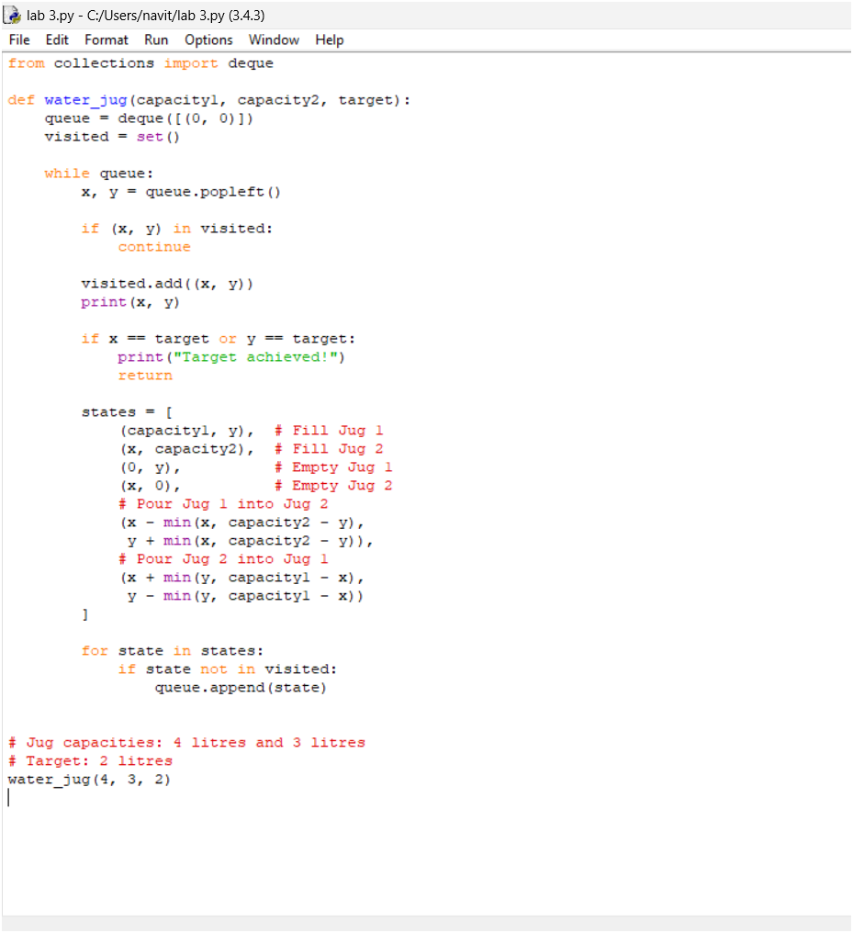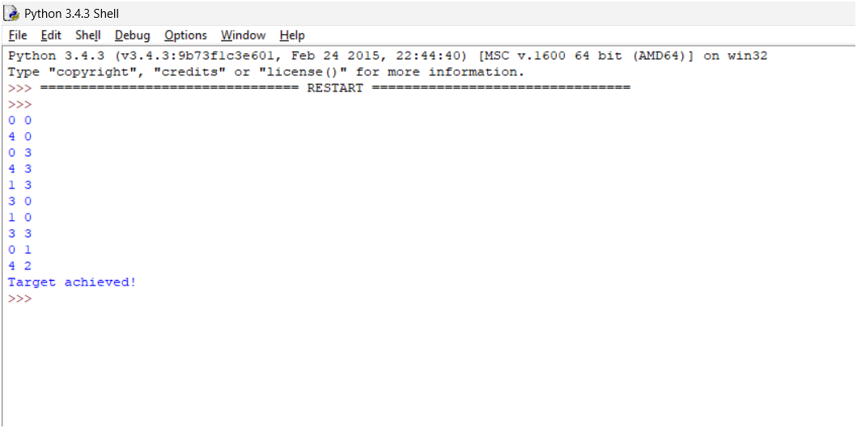
Result:
Thus, the Water Jug Problem was successfully solved using Python, and the required target amount was obtained.

